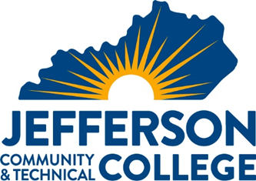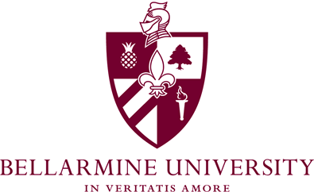

TRANSFER PATHWAY GUIDE

2021-2022
Associate in Art to Bachelors in Middle School Education
English Language Arts and Learning & Behavioral Disorders (Double Major)

Overview
Completion of the following curriculum will satisfy the requirements for Bellarmine University at the Kentucky Community and Technical College System and leads to the Associates in Arts at Jefferson Community & Technical College.

Admission Requirements
Students preparing for the teaching profession and initial teacher certification must be accepted into the teacher education program. Formal application for admission may be made upon completion of a required set of courses. Applications are obtained through the School of Education office. Transfer students desiring teacher certification must meet with the Chair to determine eligibility for admission.

General criteria for acceptance into teacher education programs are as follows:
- Evidence of specific competency levels in the following basic skills: oral and written communication, reading, writing and mathematics. Applicants to teacher education must demonstrate these competencies through their liberal arts and professional course work (including experiences in the field) and by meeting minimum score requirements on the Core Academic Skills for Educators (CASE) as follows: Reading (156), Mathematics (150), Writing (162).
- A minimum cumulative grade point average of 2.75.
- A minimum grade point average of 2.75 in the teaching major content area(s).
- A minimum grade of B- in all professional education classes, with a 2.75 cumulative grade point average in professional education courses.
- A minimum grade of C+ in ENG 101; COM 181
- Middle School majors – a minimum grade of C+ in MAT 205 and MAT 206.
- Receipt of satisfactory recommendations from instructors of Education courses, selected General Education courses, and cooperating teachers of field-based experiences.
- Appropriate teacher dispositions as delineated by the School of Education. Click here to access form.
- Code of Ethics.
- Admission interview that assesses Critical Thinking, Creativity, Collaboration, and Communication.

Degree Requirements
A minimum of 200 field hours are required prior to Student teaching. Courses may require field hours beyond regular class meetings. Additional field hours may be required.

Additional Information
Student’s may choose to double major with AAS in Education and Associates in Art to maximize the number of courses taken at Jefferson and transferred to Bellarmine. Speak with your Jefferson advisor for details. *Courses will not meet additional field hours requirements.

Student can also take IEC 120, EDU 240, and EDP 260 at Jefferson if they have the financial means to pay for courses.

KCTCS AA to Bachelors in Middle School Education- English Language Arts & LBD CHECKLIST

Jefferson Community and Technical College

Category 1: KCTCS General Education Core Requirements (33 hours)
KCTCS Course | Course or Category | Credits | Bellarmine  Course | Notes
ENG 101 | Written Communication I | 3 | ENGL 101
ENG 102 | Written Communication II | 3 | ENGL Elective
COM 181 | Basic Public Speaking | 3 | COMM 103
PSY 110 | General Psychology | 3 | PSYC 103
REL 130 | Intro. to Comparative Religion | 3 | THEO 200
POL 101 | American Government | 3 | PS 101
HIS 101 or HIS 102 | World Civilization I or World Civilization II | 3 | HIST 116 or  HIST 117
PHI 100 | Intro. to Philosophy | 3 | PHIL 101
BIO 112 &  BIO 113 | Intro. To Biology & Lab | 4 | BIO 115 & BIOL 115L
MAT 146 or  MAT 150 | Contemporary College Mathematics or College Algebra | 3 | MATH 107 or MATH 105
GLY 101& 111 or  GLY 110 & 114 or  CHE 140 & 145 | Physical Geology w/lab or  Environmental Geology w/lab or  Intro. to Chemistry w/lab | 4 | ENVS 130/130L or  CHEM 109/109L
 | Subtotal General Education Courses | 35
*Science courses must have labs to meet Bellarmine requirements.
Category 2: KCTCS AA Requirements (6 hours)
KCTCS Course | Course or Category | Credits | Bellarmine  Course | Notes
ENG 251 | Survey of American Literature I | 3 | ENGL Elec. 300
ENG 252 | Survey of American Literature II | 3 | ENGL 324
 | Subtotal AA/AS Requirement Courses | 6

Category 3: KCTCS Electives (21 hours)
KCTCS Course | Course or Category | Credits | Bellarmine  Course | Notes
FYE 105 | First-Year Experience | 3 | GEN- Elective
EDU 204 | Technology in the Classroom | 3 | EDUC 316
MAT 205 | Math for Elem. & Middle School Teaching I | 3 | MATH 101
MAT 206 | Math for Elem. & Middle School Teaching II | 3 | MATH 102
EDU 201 | Intro. to American Education | 3 | EDUC 200
EDP 202 | Human Development and Learning | 3 | EDUC 102
EDP 203 | Teaching Exceptional Learnings | 3 | EDUC 220
 | Subtotal Elective Courses | 21
 | TOTAL Associate Degree Hours | 62
Updated: October 2021

