Graduation List Report

This report allows you to obtain graduation lists from past semesters and/or upcoming semesters. You can obtain the entire graduation list or limit it to a specified major. This report can only be run by Bellarmine faculty or staff members and only from an on-campus location. Using Internet Explorer is recommended.

- Go to the SSRS server by following this link: Public Registrar Reports folder on SSRS.

- You’ll be presented with a logon prompt. Enter your regular username, but prefaced with BELLARMINE\. For example, BELLARMINE\aolsen and then your regular password.

- Select the Graduation List report by clicking on it. You’ll be presented with a Terms & Conditions page. Read it, click the I Agree button, and the report’s parameters will be displayed.

Here’s how the screen will look at that point:

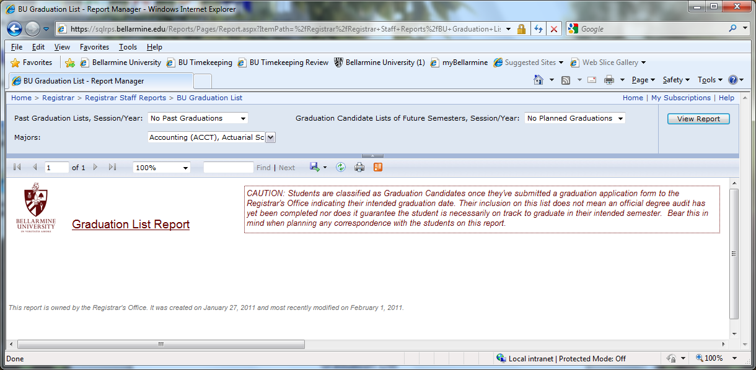:
- To obtain past graduation lists, use the pull down on the left to select the session/year you want (leave the pull down on the right as it is). If you only want certain majors to appear, select that major from the pull down; otherwise leave it as is. Then click the View Report button on the far right (you may need to scroll over to see it). Note: if you are looking for a graduation list prior to those available on this report, please contact the Office of Institutional Research.

- To obtain future graduation lists, use the pull down on the right to select the session/year you want. Leave the pull down on the left as it is. If you only want certain majors to appear, select that major from the pull down; otherwise leave it as is. Then click the View Report button on the far right (you may need to scroll over to see it). Note: please keep in mind that students are constantly being added and removed from this list. The closer it is to the graduation the more accurate the list will be. The list is considered “final” on graduation day at which time it will be moved over to the past graduation report. Read the “Caution” box at the top of the report for more information.

- If you have any questions about this report, contact Ann Olsen, Registrar, at aolsen@bellarmine.edu or 272-8230.

